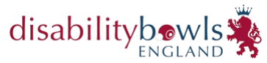
Inter Club Triples

Venue: Honiton I B C
Bowling Green Ln, Streamers Meadows, Honiton
EX14 2DP
Date: Saturday 12th March 2022

Start Time: Report 9.00am for 9.30am

Dress Code: Generic DBE Shirts,
Navy Trousers or Shorts.

Entry Open DBE Members from the
same club

Entry £5.00 per player

Please submit entry form with fee by 14th February 2022 to:
Stuart Espie, Competitions Secretary, Disability Bowls England, 19 Meadow Way, Leighton Buzzard, LU7 3XN or via email competitions@disabilitybowlsengland.org.uk
Cheques made payable to ‘Disability Bowls England’.
Payment by BACS will be accepted - TSB – Sort Code - 30 – 66 – 95
Account No. 23809968
Please add your initials and ICTH as the reference.
NAME
NAME
NAME
CONTACT NUMBER
EMAIL ADDRESS

Kindly note that the competition will be run in line with Government & NGB Covid-19 Guidance in place at the time of the event, full details of which will be emailed before the date.

