Ilford & District Indoor Bowls Club Ltd
Mixed Gala Competition 12th February 2022

After a year without any serious bowls competitions because of Covid restrictions, Ilford & District Indoor Bowls Club finally held its long awaited and popular mixed Gala Day on the 12th February.

Teams from as far away as Clacton, Hoddesdon and Dartford joined 13 other local indoor and outdoor clubs in Ilford’s own unique bowling format with the top teams from each of two groups group playing each other in the grand final.

The final this year was contested between Wanstead Central Bowls Club and Hoddesdon and Rye Park Bowls Club with Wanstead Central narrowly beating Hoddesdon and Rye to take the IIBC Gala trophy and a very nice cash prize as well.

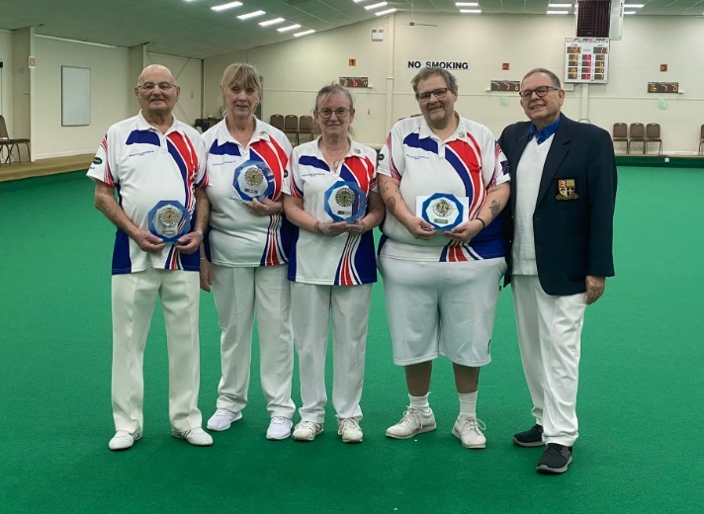

From left to right:-

Gerry Rose – Sandra Dupuy – Wendy Gray – Mark Newman and IIBC General Secretary – Alan Jaye

The guest of honour was the Mayor of Redbridge, Councillor Roy Emmett who addressed the teams and supporters and also took to the green to show the players how the game should be played!

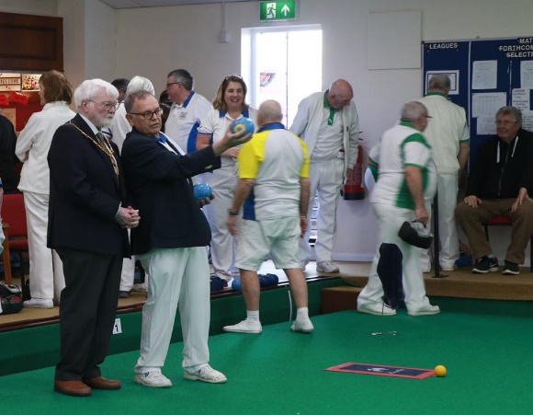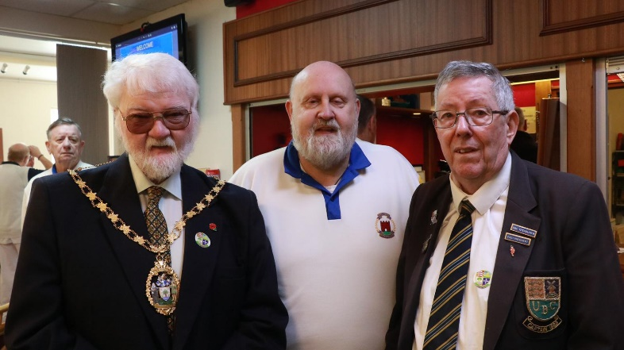

The Mayor “lining up his shot” with General Secretary Alan Jaye | Councillor Roy Emmett with Club Manager Bob Hayter and Chairman Sandy Dron

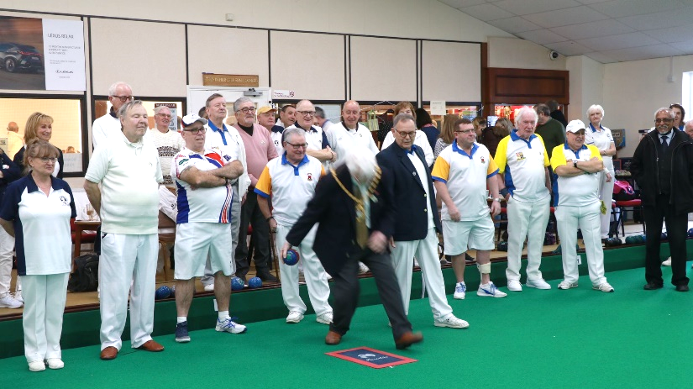

We were privileged to welcome two exceptional Disability Bowls England Internationals. Michelle White from Swale IBC and VCD Bowls Club Crayford, representing Stone Lodge Bowls Club Dartford in this competition, who has been chosen to represent England in this year’s Commonwealth Games at Leamington and Colin Milner from Hoddesdon and Rye Park Bowls Club who narrowly missed out on winning this year’s competition.

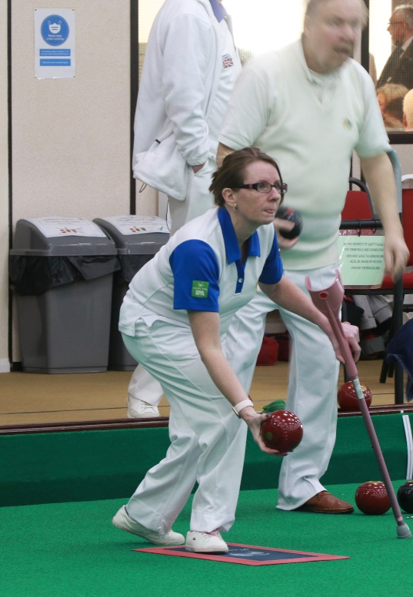

DBE International - Michelle White  Swale IBC & VCD Bowls Club Crayford | DBE International - Colin Milner  Hoddesdon & Rye Park

The atmosphere was electric and the standard of bowls, superb. The Club were delighted that so many supporters and Club members turned out to watch and help and were treated to a sumptuous finger buffet lunch provided by Dawn’s Catering.

The event was sponsored by LEXUS Woodford and the catering by Remedy Medical Recruitment.

We look forward to our next major event, a public open day which we hope to hold in October or November 2022. New members of all ages and abilities are welcome and coaching is available by request.

