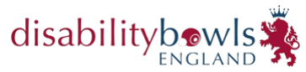
National Classified Singles

Venue: Gedling I B C
Foxhill Road, Carlton, Nottingham NG4 1RL

Date: Saturday and Sunday 25th
and 26th February 2023

Start Time: Report 9.00am for 9.30am

Dress Code: Generic DBE Shirts,
Navy Trousers or Shorts.

Entry Open to all DBE Members who have
a Physical Disability Classification

Entry £5.00 per player

Please submit entry form with fee by 24th January 2023 to:
Stuart Espie, Competitions Secretary, Disability Bowls England, 19 Meadow Way, Leighton Buzzard, LU7 3XN or via email competitions@disabilitybowlsengland.org.uk
Cheques made payable to ‘Disability Bowls England’.
Payment by BACS will be accepted - TSB – Sort Code - 30 – 66 – 95
Account No. 23809968
Please add your initials and ICS as the reference.
NAME and CLASSIFICATION
CONTACT NUMBER
EMAIL ADDRESS

Kindly note that the competition will be run in line with Government & NGB Covid-19 Guidance in place at the time of the event, full details of which will be emailed before the date.

