National Open Pairs
Venue: Stoke B C
Occupation Rd, Coventry CV2 4AB

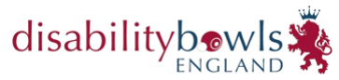
Date: Sunday 22nd June 2024

Start Time: Report 9.00am for 9.30am

Dress Code: Generic DBE Shirt,
Navy Trousers or Shorts

Entry Open to All DBE Members

Entry £5.00 per player (£10 per pair)

If you do not have a playing partner, we will try to create pairs from single entries. Entry Fee will not be returned for non-attendees.

Please submit entry form with fee by May 27th 2024 to:
Stuart Espie, Competitions Secretary, Disability Bowls England, 19 Meadow Way, Leighton Buzzard, LU7 3XN or via email competitions@disabilitybowlsengland.org.uk
Cheques made payable to ‘Disability Bowls England’.
Payment by BACS will be accepted - TSB – Sort Code - 30 – 66 – 95
Account No. 23809968

Please add your initials and NOP as the reference.
NAME 1
NAME 2
CONTACT NUMBER
EMAIL ADDRESS

Kindly note that the competition will be run in line with Government & NGB Covid-19 Guidance in place at the time of the event, full details of which will be emailed before the date.

